**Module 1 (Assignment)**

**SE – Overview of IT industry**

1. **What is software? What is software engineering?**

**Software:**

* In a computer system, the software is basically a set of instructions or commands that tell a computer what to do.
* In other words, the software is a computer program that provides a set of instructions to execute a user’s commands and tell the computer what to do.
* For example like MS-Word, MS-Excel, PowerPoint, etc…

**Software Engineering:**

* Software Engineering is the process of designing, developing, testing, and maintaining software. It is a systematic and disciplined approach to software development that aims to create high-quality, reliable, and maintainable software.
* Software engineering includes a variety of techniques, tools, and methodologies, including requirements analysis, design, testing, and maintenance.
* It is a rapidly evolving field, and new tools and technologies are constantly being developed to improve the software development process.
* By following the principles of software engineering and using the appropriate tools and methodologies, software developers can create high-quality, reliable, and maintainable software that meets the needs of its users.
* Software Engineering is mainly used for large projects based on software systems rather than single programs or applications.
* The main goal of Software Engineering is to develop software applications for improving quality, budget, and time efficiency.
* Software Engineering ensures that the software that has to be built should be consistent, correct, also on budget, on time, and within the required requirements.

1. **Explain Types of software**

**System Software:**

* System software is a software that is design to provide a platform to other software.
* System software control and manage the operations of computer hardware.
* Ex;

Operating system (Windows, Android, Linux, etc…)

**Application Software:**

* The software that helps you to do a specific type of works is called as application software.
* Ex;

MS Word, Excel, etc…

**Utility Software:**

* Utility software helps to manage. Maintain and control computer resources.
* Ex;

Antivirus software, Backup software, Disk tools, etc…

**Driver Software:**

* A software driver is a type of software program that controls a hardware device. On any computer, smartphone, tablet, different hardware components that are part of the computer and attached devices need to communicate with each other for a computer to function and work.
* Ex:

BIOS, Motherboard drivers, etc…

**Middleware Software:**

* Middleware is software that bridges gaps between other applications, tools, and databases in order to provide unified services to users. It is commonly characterized as the glue that connects different software platforms and devices together.
* Ex;

API, Database middleware, etc…

**Programming Software:**

* In order to make a computer functional, a set of instructions need to be programmed, as these programmed languages are carriers to the performance of a task.
* Ex;

Python, C, C++, Java, etc…

1. **What is SDLC? Explain each phase of SDLC.**

**SDLC:**

* It is a step by step procedure to develop a new software.
* It stands for “Software Development Life Cycle”

**When SDLC Start?**

* When company wants to starts with new project, they start with SDLC.

**Why should we follow SDLC?**

* We will to get to know how many engineers are required to work on the project.
* We will not get to know how much cost to be invested on the project.
* There might not be proper supporting requirement document.
* Chances are there we might delay in releasing software to customer.

**Diagram for SDLC:**

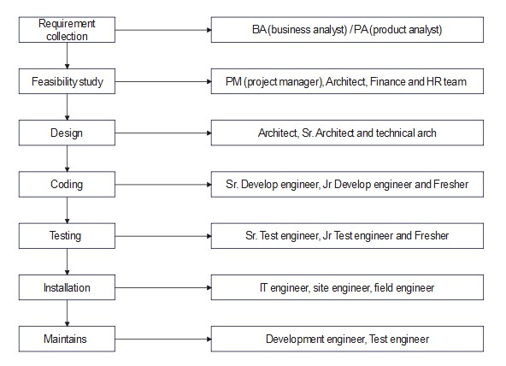

**Requirement Collection:**

* It’s a requirement collection from customer place, BA will go to customer place and collect requirements in Business language and come back to company and convert into software language and explain it to develop and test engineers. BA will act a bridge between company and customer.

**Who can become BA?**

* Domain expert (if a person is having around 15 to 20 yr experience in same domain and has got good knowledge on domain is called Domain expert).
* SR. developer (person has worked on same project for around 8 to 10 years and has got a good knowledge on the project.
* SR. test engineer (person has worked on same project for around 8 to 10 years and has got a good knowledge on the project.

**NOTE:**

* 70 to 80 per of critical and complex and for bigger projects BA will be present.
* 20 to 30 per of small and simple projects BA might not be present, so in that case Sr. Dev or Sr. Test engineer will play role of BA.

**Feasibility Study:**

* Once requirement collection is done then we go for feasibility study. It is done by a team which consists of Project Manager, Architect, BA, Finance team and HR team.
* This is the stage where company will decide to take up project or not and if we take up the project then company will check for sufficient resources, technologies, lab setups and this is the stage where company will get to know if the company will get profit or not, this process is known as feasibility study.
* **Role of Project manager:** PM will interact with BA, finance team and HR team and gather the information and PM will decide to take up project or not. Finance team and HR team can be optional.
* **Role of Architect:** Architect will always think from technical view and he will decide technically is it possible to implement the project or not, if it is possible which kind of technology to be used, this decision will be taken by architect.
* **Role of BA:** BA will be involved in requirement. BA will go to customer place and collect requirements in Business language and come back to company and convert into software language and explain it to develop and test engineers. BA will act a bridge between company and customer.
* **Role of finance team:** Finance team will always think from money point of view and they will see what is the operational cost required to work on project and if they invest money do they get profit or not.
* **Role of HR:** HR will always think from hiring/ resource point of view. How will check how many experience and fresher’s are required.

**Design:**

**What is High Level Design (HLD)?**

* High-level design or HLD refers to the overall system, a design that consists description of the system architecture and design and is a generic system design that includes:

1. System architecture
2. Database design
3. Brief description of systems, services, platforms, and relationships among modules.

**What is Low Level Design (LLD)?**

* If you take any application designing each and every individual module in detailed is called as low-level design.

**Coding:**

* Once after design is completed, we go for coding stage or phase. It is done by Sr. developers, Jr. Developers and fresher’s by looking into LLD and requirement.

**Testing:**

* Once after coding is completed developer will give software to test engineers, where in all test engineers (Senior, junior, fresher’s) will start to test the software by entering all possible inputs into software to find defects in the software according to customer requirement is called as testing.

**Installation:**

* Once after the coding and testing is done if software quality is good then we go for installation stage. It is done by IT engineer or site engineer or field or release or installation or implementation engineer.
* IT engineer from company will go to customer place and setup the environment to install the software so that customer can use the software, run business this process is called as installation.

**Maintenance:**

* Once after installation is done customer start using s/w for business. While using software if customer face any problems software company will fix the defects for customer with free of cost for certain period.

**Ex;**

Maybe 6moths or 1 year depending on the agreement between customer and the company. This period called as Maintenance period.

**Who will be involved in maintenance?**

* In maintenance same old development and test engineers who developed and tested the products will be involved but size of team size is small because the amount of work is done is less. They might add/modify/remove features as well as they might fix the bugs too.

1. **What is DFD? Create DFD on Flipkart.**

* A Data Flow Diagram (DFD) is a traditional visual representation of the information flows within a system. A neat and clear DFD can depict the right amount of the system requirement graphically.
* It shows how data enters and leaves the system, what changes the information, and where data is stored.

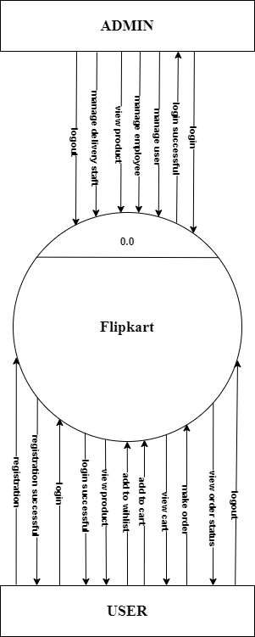

**DFD Level – 0**

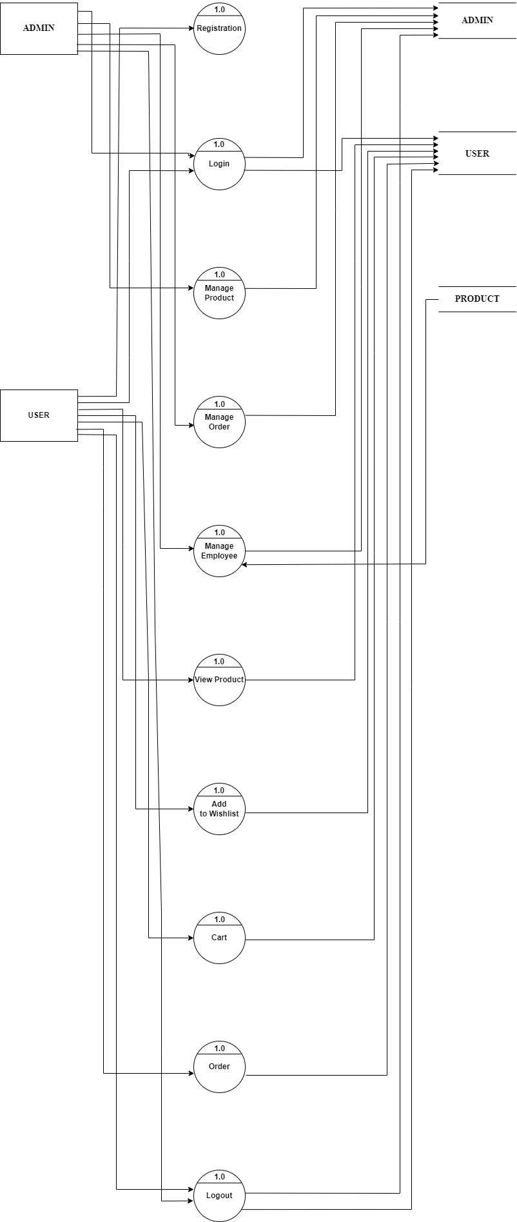

**DFD level: 1**

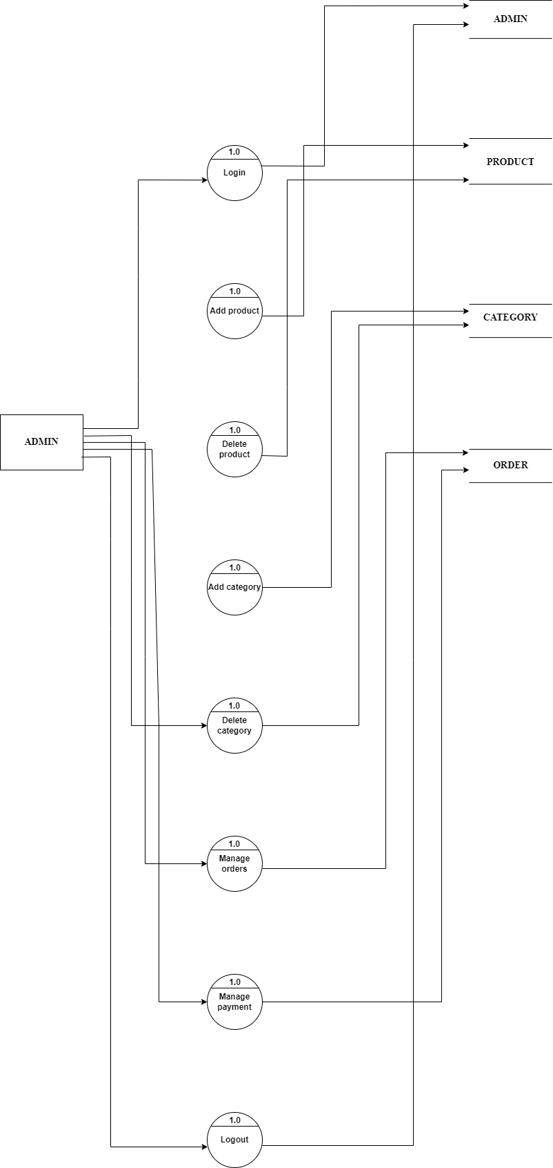

**DFD level: 2 (ADMIN Diagram)**

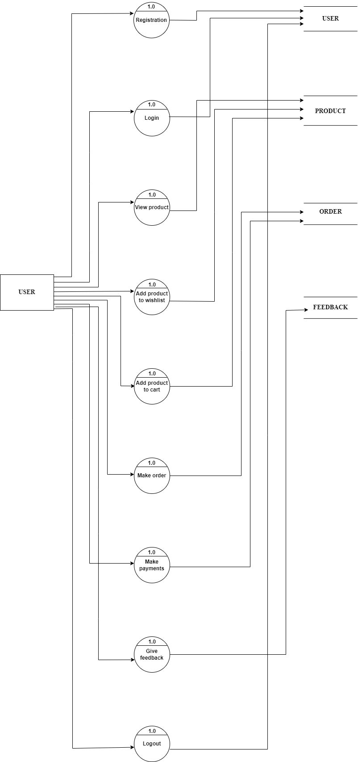

**DFD level: 2 (USER Diagram)**

1. **What is Flowchart? Create a flowchart to make addition of two numbers.**

**Flowchart:**

* Flowchart is a graphical representation of an algorithm. Programmers often use it as a program-planning tool to solve a problem. It makes use of symbols which are connected among them to indicate the flow of information and processing.
* The process of drawing a flowchart for an algorithm is known as “flowcharting”.

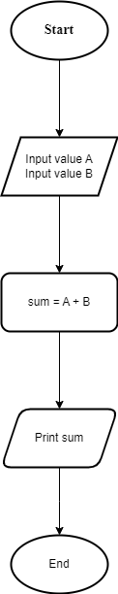

1. **What is Use case Diagram? Create a use-case on bill payment on paytm.**

**Use case Diagram:**

* A use case diagram is used to represent the dynamic behavior of a system. It encapsulates the system's functionality by incorporating use cases, actors, and their relationships. It models the tasks, services, and functions required by a system/subsystem of an application. It depicts the high-level functionality of a system and also tells how the user handles a system.

